**Practical-1**

**Aim: Track engagement with home page and other site content.**

Track engagement with home page and other site is content in a similar web tools use for it.

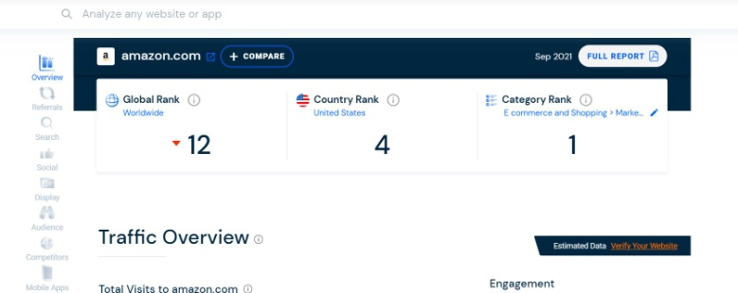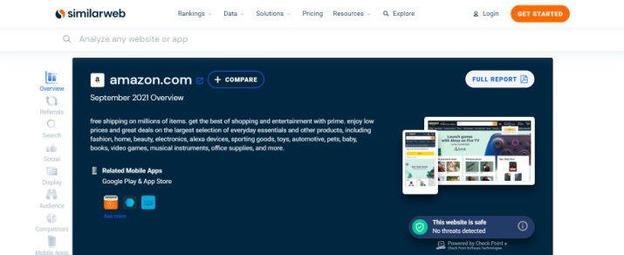  
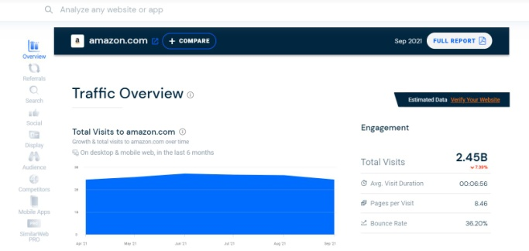 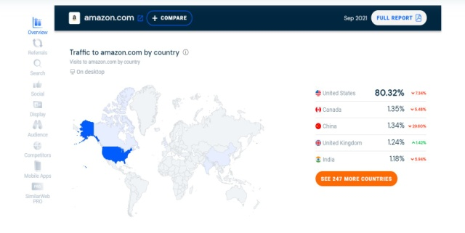

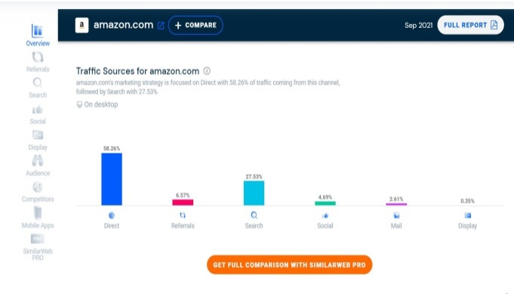 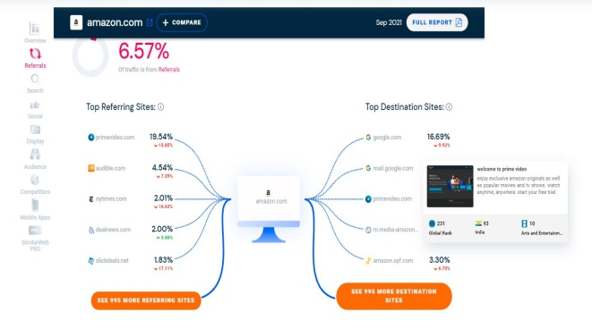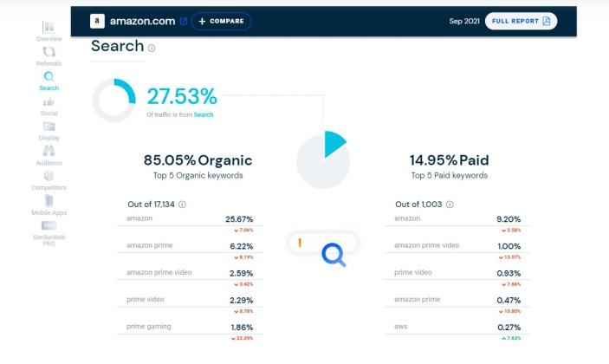 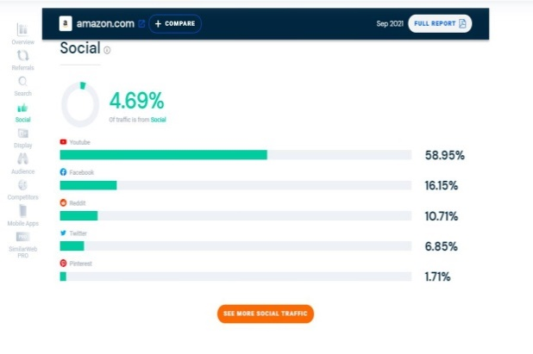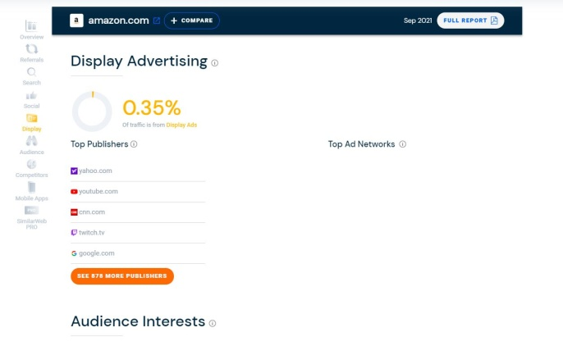 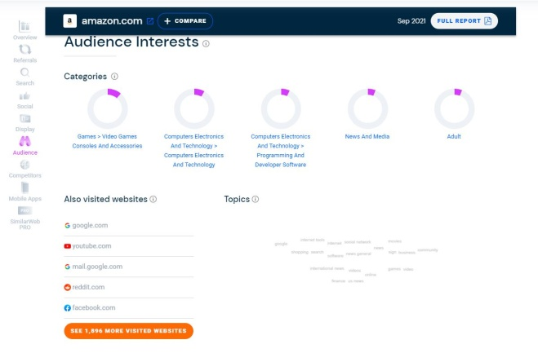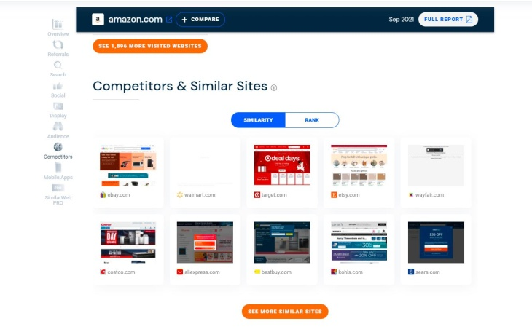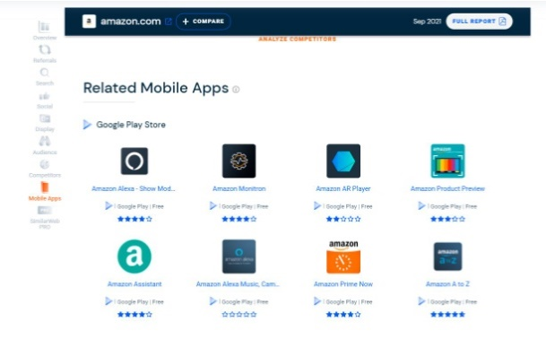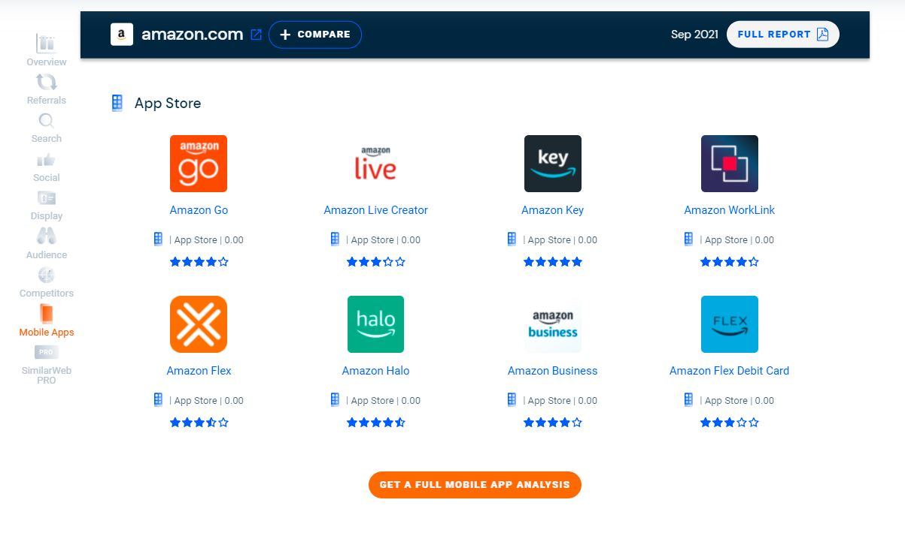

**Conclusion:**

In this experiment we learn track home page or other site use similaweb.com tools.

**Practical-2**

**Aim: Measure the time taken to load home page and other pages.**

Page load time plays a decisive role in determining website ranking. A website that loads faster is bound to rank well and gain significant growth in organic traffic.

Key Metrics for checking website load time:

* TTFB: Time to First Byte (TTFB) represents the time taken by a web or mobile browser to receive the first byte of response from the server after it requests a specific URL.
* Page load time: Represents the time taken to completely display the content of a specific page.
* Response Time: Represents the time taken to fully receive the first response from the server.
* DOM Processing Time: Represents the time required to parse the HTML into a DOM and retrieve or execute scripts.

There are so many tools to check the load time of webpage. Here we are going to use Google PageSpeed Insights.

Steps to check the loading time:

1. Visit Google PageSpeed Insights.
2. Enter the URL of the website.
3. Click on the Analyze button.

Here, we are going to measure the loading time of [www.spec.edu.in](http://www.spec.edu.in) website.

OUTPUT:

Here we got the output for desktop platform:

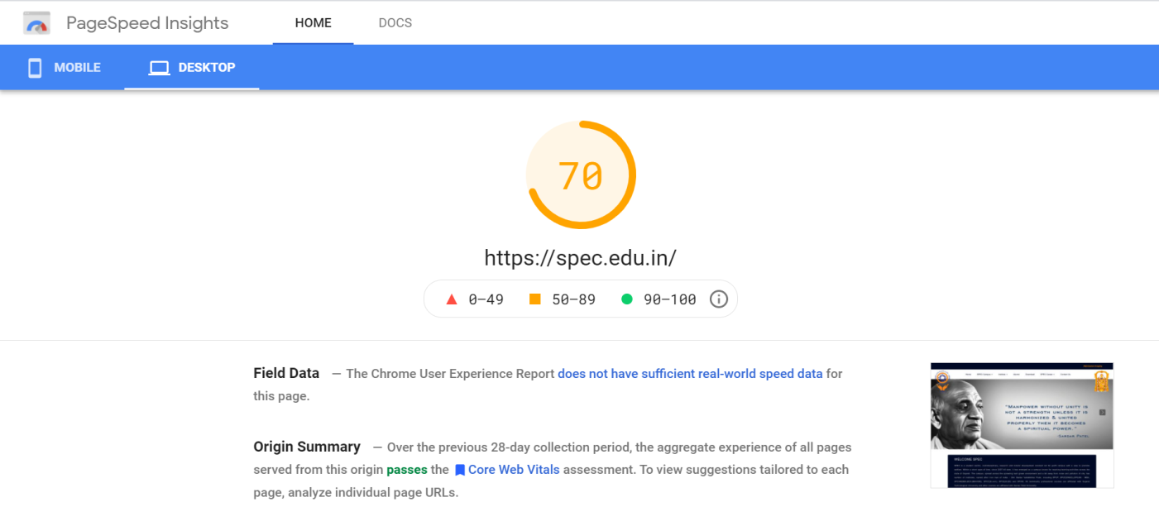

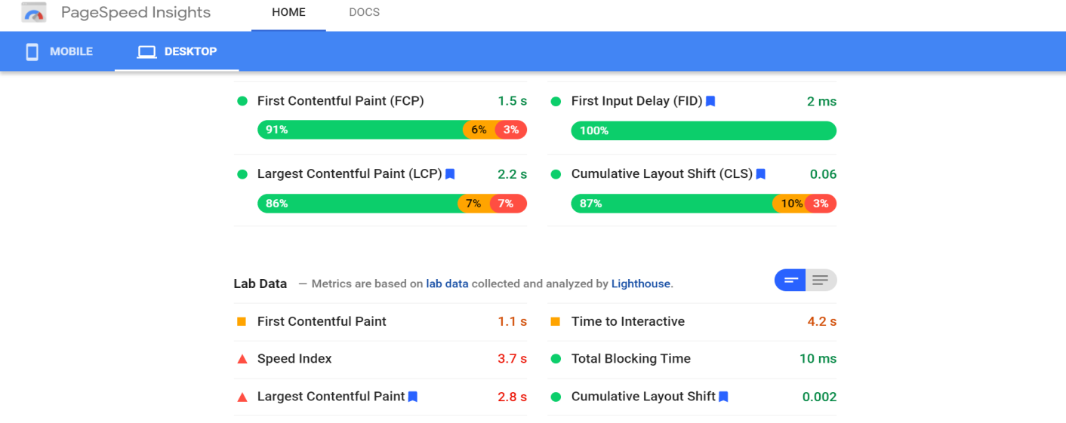

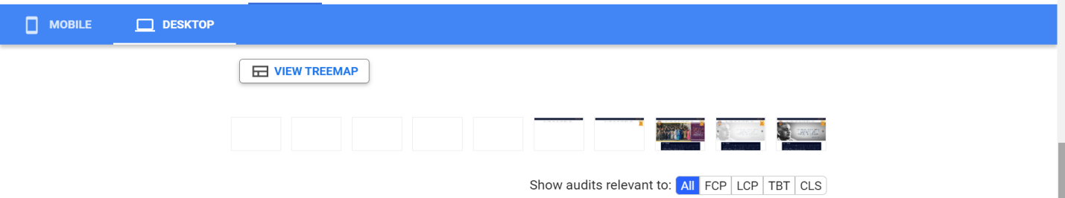

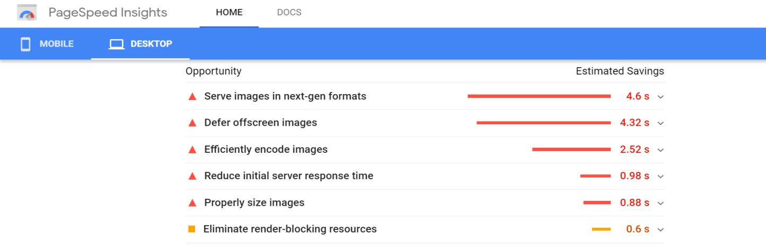

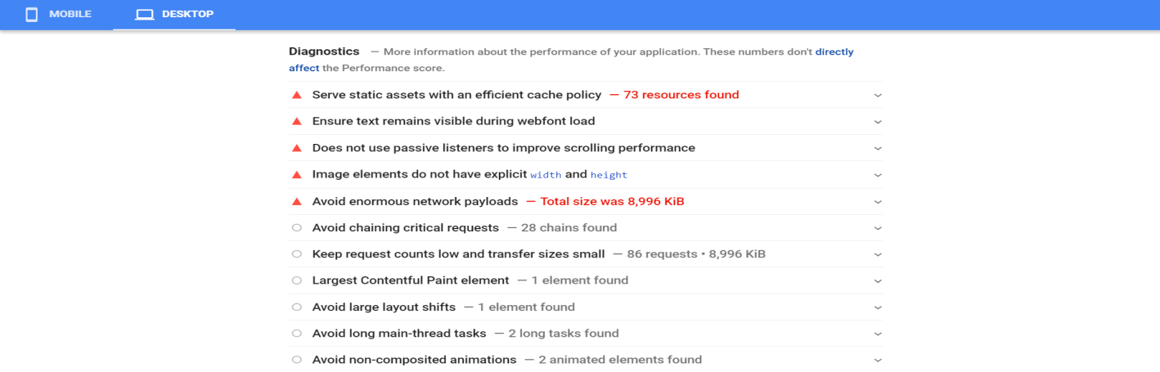

Now we have the output for same website for mobile:

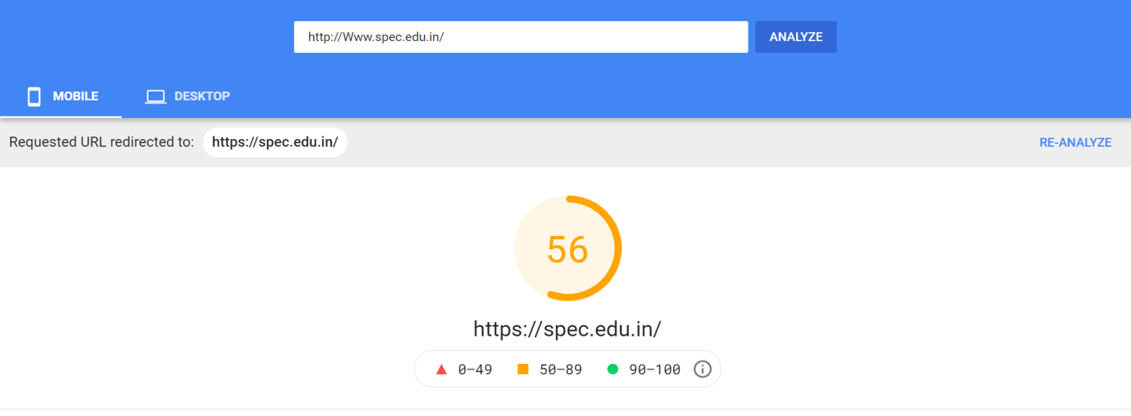

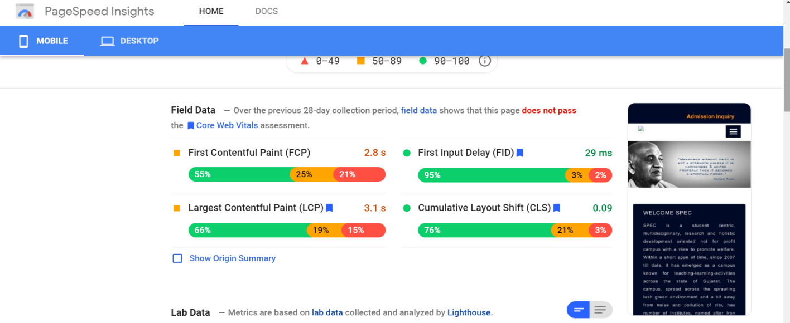

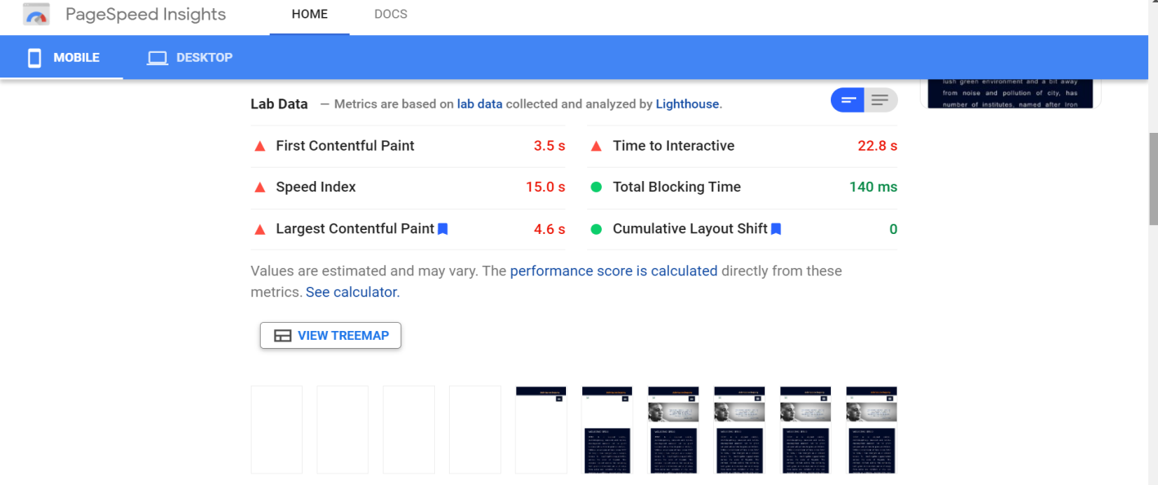

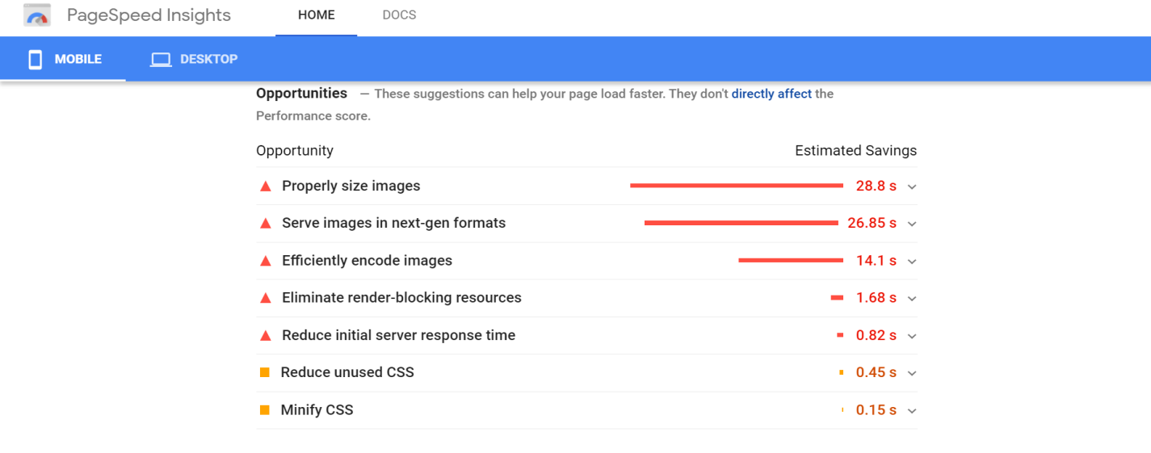

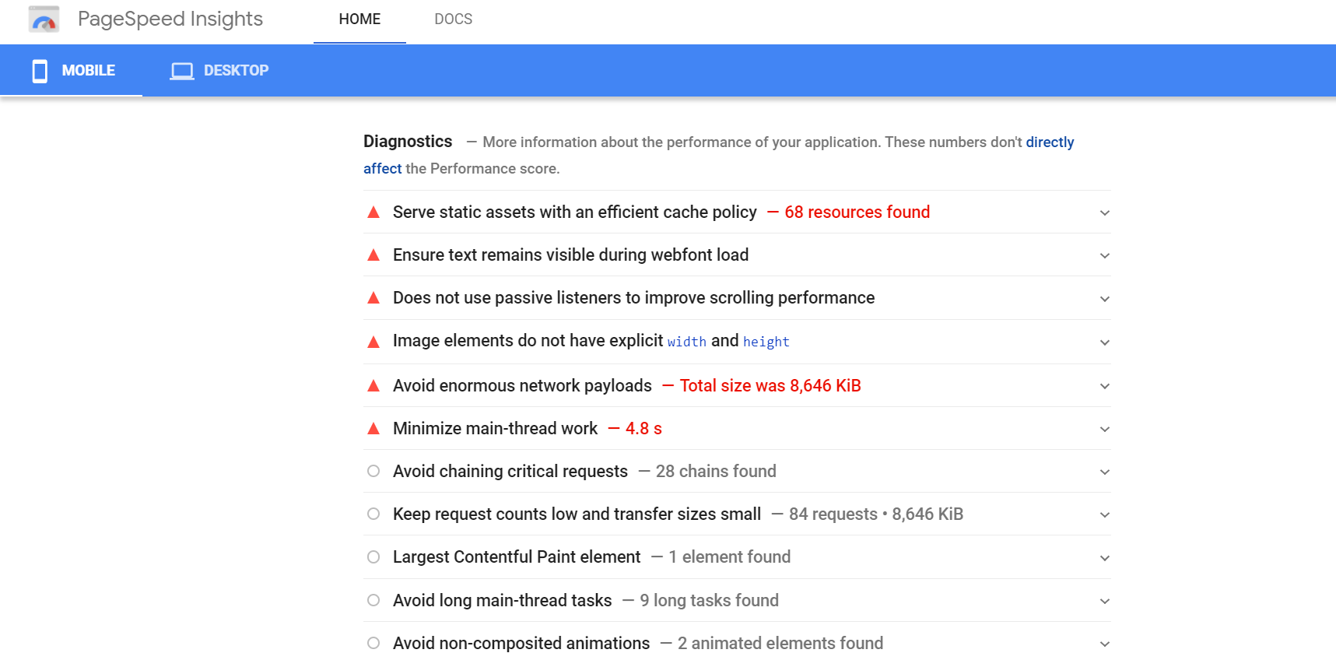

**Conclusion:**

In this experiment we learned about the page load time and perform practical to find the page load time for website as well as through this experiment we came to know about how the components of the webpage load and how much time are taken to load them.

**Practical-3**

**Aim: Perform A/B testing**

**1. Site Search**

Site search bars help users quickly find what they’re after on a particular website. HubSpot found from previous analysis that visitors who interacted with its site search bar were more likely to convert on a blog post. So, we ran an A/B test in an attempt to increase engagement with the search bar.

In this test, search bar functionality was the independent variable and views on the content offer thank you page was the dependent variable. We used one control condition and three challenger conditions in the experiment.

In the control condition (variant A), the search bar remained unchanged.

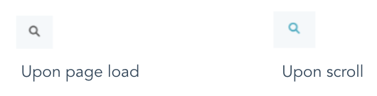

In variant B, the search bar was made larger and more visually prominent, and the placeholder text was set to “search by topic.”

variant b of the hubspot search bar AB test

Variant C appeared identical to variant B, but only searched the HubSpot Blog rather than the entire website.

In variant D, the search bar was made larger but the placeholder text was set to “search the blog.” This variant also searched only the HubSpot Blog

variant c of the hubspot search bar AB test

We found variant D to be the most effective: It increased conversions by 3.4% over the control and increased the percentage of users who used the search bar by 6.5%.

**2. Mobile CTAs**

HubSpot uses several CTAs for content offers in our blog posts, including ones in the body of posts as well as at the bottom of the page. [**We test these CTAs extensively**](https://blog.hubspot.com/marketing/ab-testing-ctas) for optimize their performance.

For our mobile users, we ran an A/B test to see which type of bottom-of-page CTA converted best. For our independent variable, we altered the design of the CTA bar. Specifically, we used one control and three challengers in our test. For our dependent variables, we used pageviews on the CTA thank you page and CTA clicks.

The control condition included our normal placement of CTAs at the bottom of posts. In variant B, the CTA had no close or minimize option.

In variant C, mobile readers could close the CTA by tapping an X icon. Once it was closed out, it wouldn’t reappear.

In variant D, we included an option to minimize the CTA with an up/down caret.

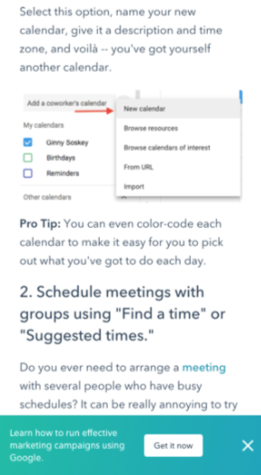

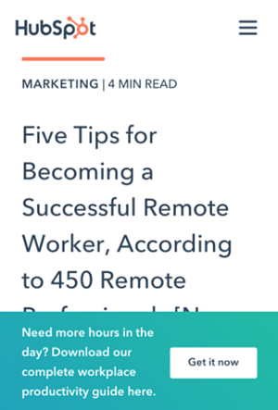

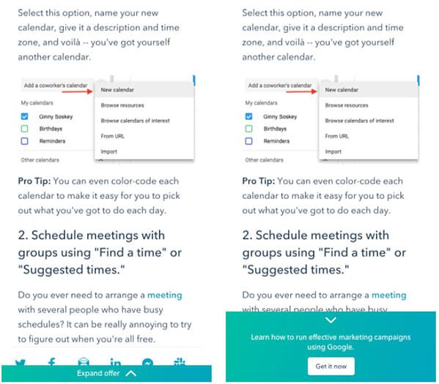

Our tests found all variants to be successful. Variant D was the most successful, with a 14.6% increase in conversions over the control. This was followed by variant C with an 11.4% increase and variant B with a 7.9% increase.

**3. Author CTAs**

In another CTA experiment, HubSpot tested whether adding the word “free” and other descriptive language to author CTAs at the top of blog posts would increase content leads. Past research suggested that using “free” in CTA text would drive more conversions and that text specifying the type of content offered would be helpful for SEO and accessibility.

In the test, the independent variable was CTA text and the main dependent variable was conversion rate on the content offer form.

In the control condition, author CTA text was unchanged (see the orange button in the image below).

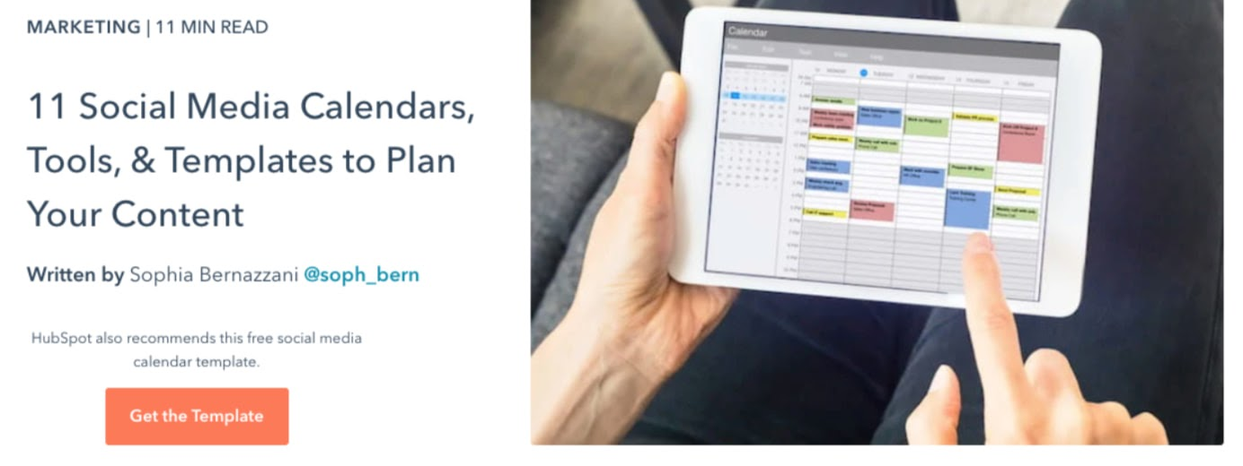

In variant B, the word “free” was added to the CTA text.

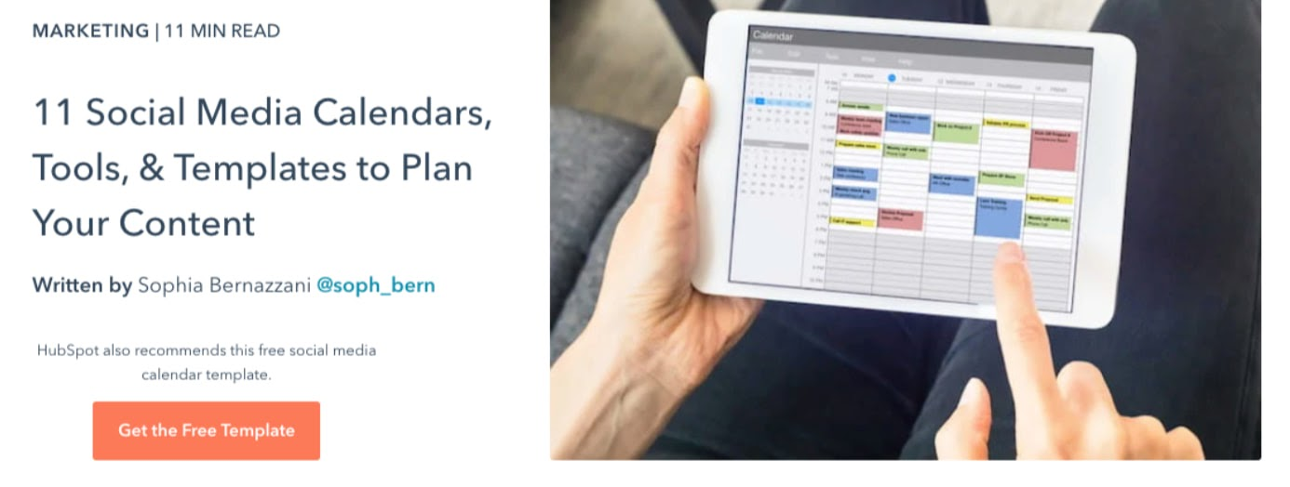

In variant C, descriptive wording was added to the CTA text in addition to “free.”

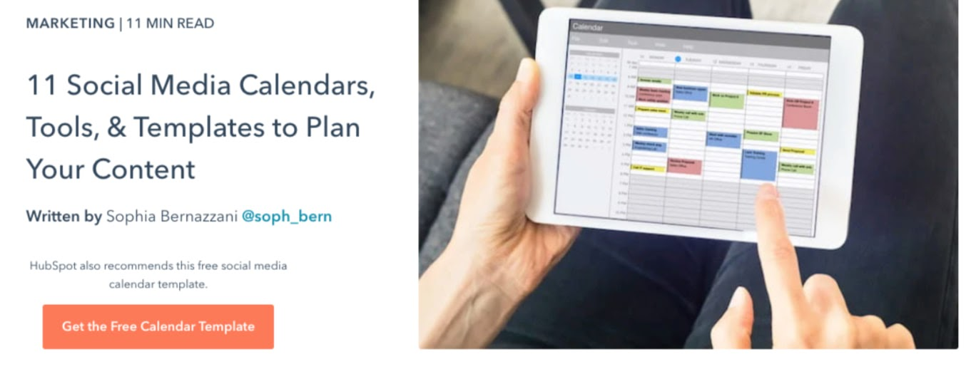

Interestingly, variant B saw a loss in form submissions, down by 14% compared to the control. This was unexpected, since including "free" in content offer text is widely considered a best practice.

Meanwhile, form submissions in variant C outperformed the control by 4%. It was concluded that adding descriptive text to the author CTA helped users understand the offer and thus made them more likely to download.

**4. Blog Table of Contents**

To help users better navigate the blog, HubSpot tested a new Table of Contents (TOC) module. The goal was to improve user experience by presenting readers with their desired content more quickly. We also tested whether adding a CTA to this TOC module would increase conversions.

The independent variable of this A/B test was the inclusion and type of TOC module in blog posts, and the dependent variables were conversion rate on content offer form submissions and clicks on the CTA inside the TOC module.

The control condition did not include the new TOC module — control posts either had no table of contents, or a simple bulleted list of anchor links within the body of the post near the top of the article (pictured below).

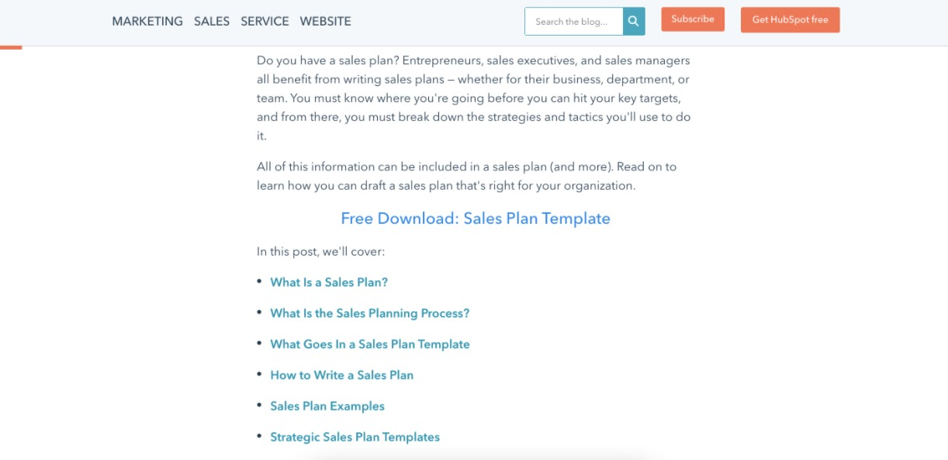

In variant B, the new TOC module was added to blog posts. This module was sticky, meaning it remained onscreen as users scrolled down the page. Variant B also included a content offer CTA at the bottom of the module.

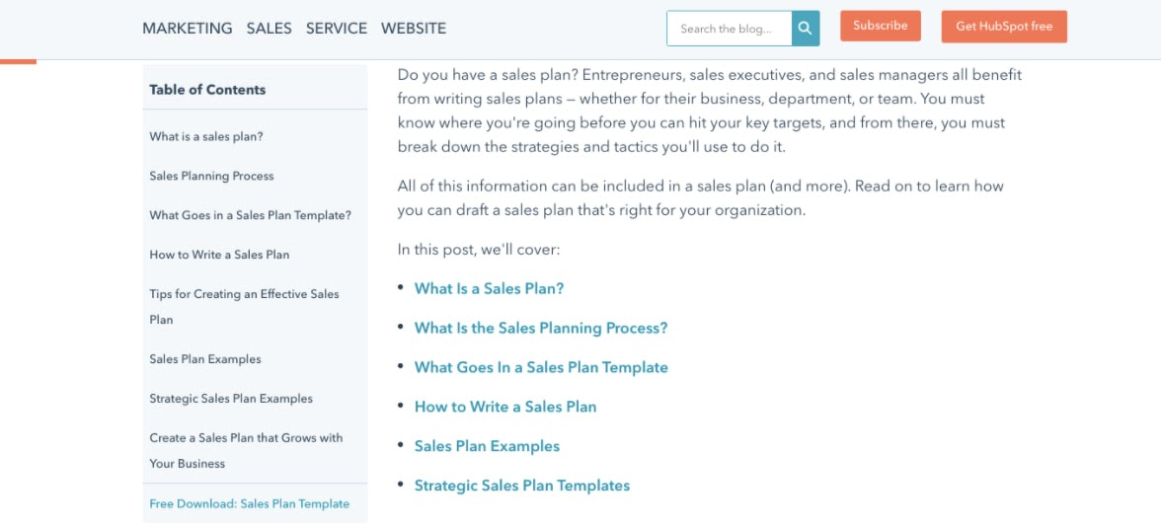

Variant C included an identical module to variant B but with the CTA removed.

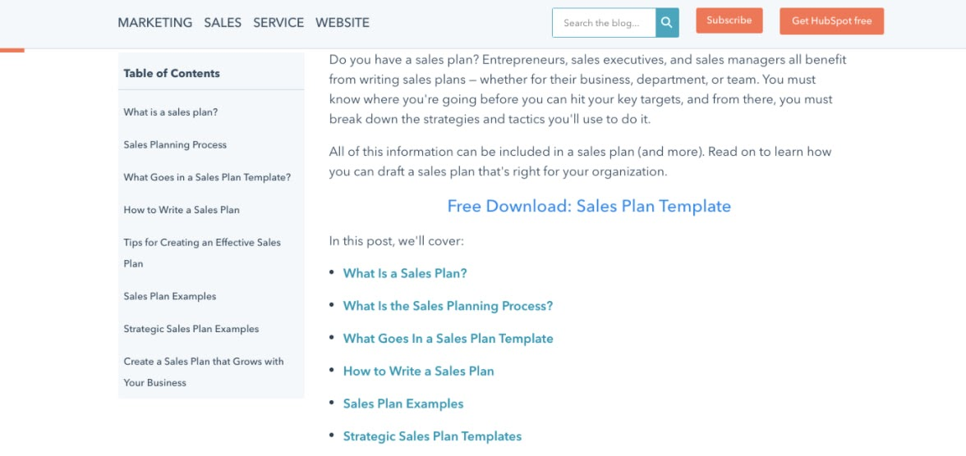

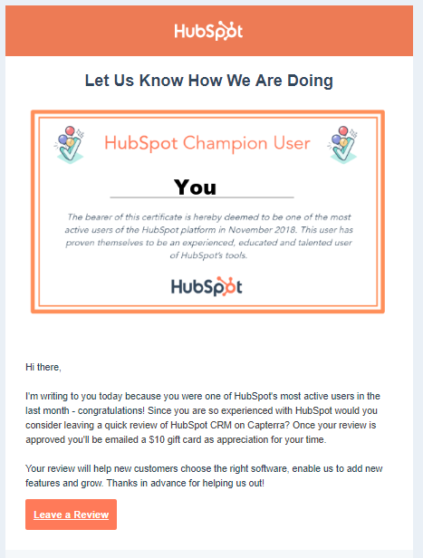Both variants B and C did not increase the conversion rate on blog posts. The control condition outperformed variant B by 7% and performed equally with variant C. Also, few users interacted with the new TOC module or the CTA inside the module.

**5. Review Notifications**

To determine the best way of gathering customer reviews, we ran a split test of email notifications versus in-app notifications. Here, the independent variable was the type of notification and the dependent variable was the percentage of those who left a review out of all those who opened the notification.

In the control, HubSpot sent a plain text email notification asking users to leave a review. In variant B, HubSpot sent an email with a certificate image including the user’s name.

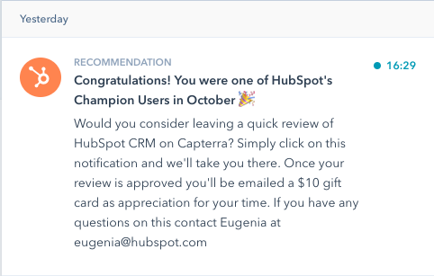

For variant C, HubSpot sent users an in app-notification

Ultimately, both emails performed similarly and outperformed the in-app notifications. About 25% of users who opened an email left a review versus the 10.3% who opened in-app notifications. Emails were also more often opened by users.

**Conclusion:**

In this experiment we learned how to perform A/B testing, hence you should always run your tests until there's at least a 95% likelihood that the new variation will increase conversions. Your tests should last for a minimum of seven days in order to make sure the results can stand up over time.

**Practical-4**

**Aim: Use cookies to store username.**

* What is a cookie?

Cookies are like a small package of information that is stored by the user’s browser. Cookies persist across multiple requests and browser sessions that should be set so that they can be a great method for authentication in web applications.

* Sometimes we will have some queries about which is to be used -- either local storage or cookies?

The local storage can be read on the client-side, whereas the cookies are being read on the server-side. The biggest difference is the data size is about to store, the local storage will give more space to store, whereas the cookie is limited by the size of to store.

The cookie is a small table which will contain key and data values so, by using this it will be very useful to carry information from one session to another session. Once we are about to store data on the server without using cookies then it will be difficult to retrieve a particular user’s information without a login on each visit to that website.

* CODE:

Function setCookie(name,value,days) {

var expires = "";

if (days) {

var date = new Date();

date.setTime(date.getTime() + (days*24*60*60*1000));

expires = "; expires=" + date.toUTCString();

}

document.cookie = name + "=" + (value || "") + expires + "; path=/";

}

function getCookie(name) {

var nameEQ = name + "=";

var ca = document.cookie.split(';');

for(var i=0;i < ca.length;i++) {

var c = ca[i];

while (c.charAt(0)==' ') c = c.substring(1,c.length);

if (c.indexOf(nameEQ) == 0) return c.substring(nameEQ.length,c.length);

}

return null;

}

setCookie("user_email","bobthegreat@gmail.com",30); //set "user_email" cookie, expires in 30 days

var userEmail=getCookie("user_email");//[NAMe@gmail.com](mailto:NAMe@gmail.com)

set and get cookie in javascript:

For storing array inside cookie :

-----------------------------------

setter : var json_str = JSON.stringify(arr); cookie.set('mycookie', json_str);

getter : cookie.get('mycookie'); var arr = JSON.parse(json_str);

----------------------------------------------------------------------------

Function common for all type of variable :

==========================================

let cookie = {

set: function(name, value) {

document.cookie = name+"="+value;

},

get: function(name) {

let nameEQ = name + "=";

let ca = document.cookie.split(';');

for( let i = 0; i < ca.length; i++ ) {

let c = ca[i];

while (c.charAt(0)==' ') c = c.substring(1,c.length);

if (c.indexOf(nameEQ) == 0) return c.substring(nameEQ.length,c.length);

}

return null;

}

}

OUTPUT:

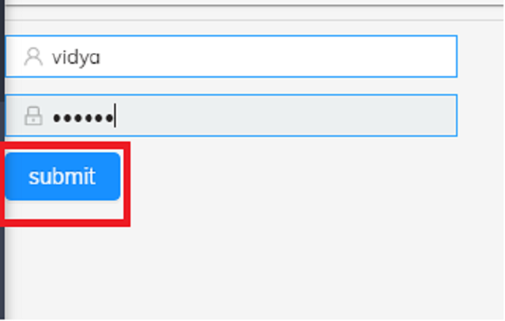

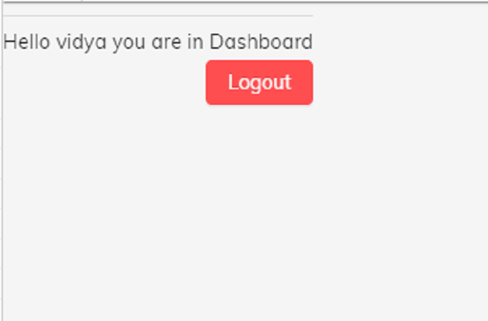

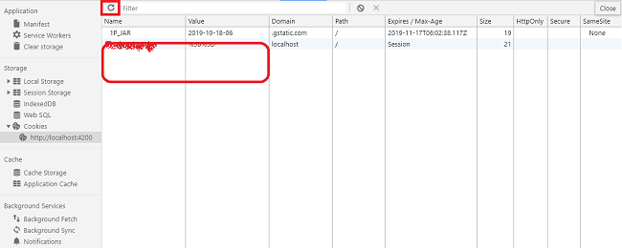

**CONCLUSION:**

In this Practical we have seen about using cookies in JAVASCRIPT for storing user’s credentials.

**Practical-5**

**Aim: Write content so that users come back to the site.**

**Theory:**

Keep Visitors Coming Back to Your Website

Whether you're a new writer or an old hand at creating content, there's plenty to learn about web copy. Grabbing your readers' attention from the first line is merely the tip of the iceberg. Once you’ve converted a site visitor into a customer, it’s time to take it a step further and keep them coming back—and turn them into brand advocates. Brand advocates are the people who are loyal users of your goods and services, and most important, are the ones who will sing your praises to others! Here are easy ways you can keep visitors coming back.

**1. Personalize Your Website:**

Providing visitors with a unique, personalized experience makes it easier to turn them into brand advocates. Here’s how you can customize their experience:

***Offer customized landing pages.***

There are several ways you can use customized landing pages to increase engagement. An easy way to implement this is by featuring products based on what customers have bought or engaged with previously. Add This features Targeting Audience overlay, helping you feature these products. Wayfair does a great job of engaging customers by showing them products they’ve already viewed, and then products in a similar wheelhouse picked for them.

***Curate a featured section.***

Showcase products or content in a special “Best of” section. It can be a large banner on your homepage or a sidebar list. The Add This Link Promotion Banner makes it easy to highlight products or content you want to draw your audience to. Whether you’re basing the showcased products on seasonal events, user behaviour, or items that need more visibility, make it relevant to the consumer. Consider creating different versions of your showcased products for different landing pages, and use them to measure performance.

***Provide new and returning visitors with relevant information.***

With Add This Audience Targeting Rules, you can create rules to show appropriate messaging to new and returning users. For example, you can create “Get started” messaging for new visitors, and “Explore more” messaging for returning visitors. Read more on How to Engage Both New and Returning Visitors to Your Website.

***Suggest content users may like.***

The best way to keep visitors on your website is to offer them content that interests them. The Add This Related Posts Tools allows you to do just that. For example, if your site focuses on selling clothing, you can engage your visitors with content about style trends; or if your site focuses on cookware, you can engage your visitors with content around organic food and recipes. The Rogers Family Coffee Company used this tool to increase engagement and saw significant results.

**2. Showcase What’s New and Popular:**

An easy way to turn visitors into brand advocates is to give them a reason to come back to your site . . . and to keep coming back. Offering new content on a regular basis and highlighting your greatest hits will foster repeat engagement.

***Highlight your new content.***

Whether you have a dedicated section, a large homepage banner, or just list content and products in chronological order, make sure visitors know that what they’re seeing is new. Also, keep it fresh. This will give visitors a reason to keep coming back. We work remotely denotes new job listings with a “new” button, so frequent visitors can scan content quickly. Sur La Table adds words like “new” and “just added” to their homepage images to highlight new products and accessories.

***Keep popular content front and centre.***

Your popular content is popular for a reason, so keep it in heavy rotation as long as it’s relevant! Keep an eye on articles that are consistently showing a decent level of traffic in Google Analytics and resurface those posts to new users. Having a section dedicated to what’s popular, or bestsellers, will also make users feel like you have a large audience; and if they enjoy the content, they’ll feel like they’re a part of your community. Lululemon’s “bestsellers” section is the first-offered list on their homepage. This gives new visitors a simple insight into what the brand’s fanbase loves.

***Emphasize highly shared content.***

The more shares a piece of content has, the more users will want to share it as well. If hundreds of people already like it, surely their Facebook friends will too! Add This Sharing Buttons offer an easy-to-implement ability to display the number of social shares content has received. See how Mercy Home grew traffic by 10 percent with Add This Share Tools.

**3. Create a Good User Experience (UX)**

Your website design and usability are two of the most important factors that influence how much time visitors spend on your site, and whether they’ll return. A clean, attractive design and easy navigation will go a long way in turning first-time visitors into brand advocates.

***Make sure your site is clear and well-designed.***

When it comes to design, keep it simple. Forget bells and whistles and focus on the essentials. Use eye-catching colours, readable fonts, and rich images and video. Don’t be afraid of whitespace! Harry’s is a beautiful, minimalist site, but an effective one. Here’s more in-depth guidelines from HubSpot to help you get started that include simplicity and hierarchy, and bring us to another point: usability.

***Make sure your site is usable — on a computer AND a phone.***

It’s not enough to have a site that looks good—it needs to be easy to navigate. Intuitive menus, clear calls to action, and robust search capabilities all make for a good user experience. And don’t forget the #1 rule—make sure your website is mobile-friendly. Zipcar is an easy-to-navigate site with all the important information you’ll need to decide whether to join right on the front page.

**4. Engage Users through Email**

Email is a great tool for engaging one-on-one with your audience, keeping them engaged with your content, or re-engaging them after they’ve abandoned your site. Personalize your emails with content that targets exactly what the consumer needs. When you provide users with specific content beyond what they can find on the website, they’ll feel “in the know” and will be more likely to become brand advocates.

***Collect emails through your website.***

A 2014 study showed that email marketing is nearly 40 times more effective at acquiring customers than Facebook and Twitter combined; 91 percent of US consumers use email daily. Calls to action to sign up for your newsletter should be prominent on your website. The Add This Overlay Tool can be used to collect email addresses. A customizable conversion lightbox pops up, prompting visitors to sign up, getting your messaging in front of everyone who visits your site. See how Minneapolis Running used audience targeting to grow their email subscribers.

***Regularly communicate via newsletter.***

Use your newsletter to highlight special offers, new content, and seasonal events. You should send your newsletter on a consistent schedule, so subscribers will know when to expect it. Too many emails will make users unsubscribe, so when you’re setting your schedule, make sure the value contained in an email warrants the frequency. Consider offering exclusive content or deals to those who are signed up, so they feel like they’re being rewarded for subscribing. The Skim has a “birthdays” section in their daily newsletter, where they highlight every subscriber celebrating that day. They also recently added a section to their newsletter, highlighting impressive feats their subscribers have accomplished.

**5. Reward Your Brand Advocates**

Once your brand advocates start spreading the word about your products or services, it’s time to say thank you. There are several ways you can reward your loyal users, including:

***Offer a personal acknowledgement.***

If you have a set of customers or users who have gone above and beyond in their demonstration of brand loyalty, you can deepen their affection for your product, site, or brand even further by reaching out to them personally. Not only does Maker’s Mark provide exclusive event offers for becoming a member of their ambassador program, but you also get your name on a real barrel of their bourbon. Once your barrel is aged and ready, you’re invited to claim a few bottles and take a complimentary distillery tour.

Maker’s Mark labels barrels with ambassadors’ names.

***Give public recognition through social media or your website.***

If someone sings your praises on Twitter, give them a shout-out! Feature testimonials on your website. Let brand advocates know that you’re listening and that you appreciate the support. The CW features a “Fan of the Week” for each show on Facebook, and also gives them an on-air plug.

***Launch an “insider’s” referral program.***

Referrals are a powerful tool for building your website audience. People tend to trust recommendations from friends and family more than businesses, and if you offer an incentive for referrals, users will be much more likely to sing your praises.

***Implementing a loyalty program.***

Loyalty programs often come with perks such as discounts, free shipping, or special gifts. You can have users sign up for yours, like Sephora’s Beauty Insider program, or it can be based on loyalty tiers—Sephora upgrades users to higher-level programs when they reach spending thresholds, and those levels come with better perks.

The bottom line: If you have a good product, you’ll have brand advocates. Engaging with them, rewarding them, and offering them value is what will keep them out there marketing your brand.

**Pre-Writing Tips**

Your content’s foundation should be laid before you start writing, and here are three key points to keep in mind.

***Tip #1: Define Your Purpose***

The single most important thing for any writer of copy is to understand its purpose. Knowing your end goal from the outset helps you craft the perfect piece of content and an ideal call-to-action statement.

The objective of the copy supports the goals of the business. So, find your answers to the questions about it:

* Is the website intended to sell a product or a service?
* Is it focused on building traffic with the intention of increasing advertising revenue or sponsorships?
* Is it aimed at attracting new clients and generating leads?
* Is the main objective to attract subscribers or build a community?

***Tip #2: Understand Your Target Audience***

Let's say selling is your primary goal. You can determine the best methods of selling only by knowing your audience. The more you know about your prospects, the better you can convert them into paying customers.

To write copy that hooks your potential customers, you need to get into their mindset:

* Who are the people coming to your site?
* What kinds of problems do they want to solve?
* What search terms would they type into a search bar?

If you can learn to write in the ways in which your visitors speak or search, you can start building up a relationship of trust. And if you answer their specific question, they may become your loyal audience and clients.

***Tip #3: Know Your Competitors***

It's also a good move to do some research on the websites of your competitors.

It’s likely that visitors to your website will also be considering the competition, so you need to make a strategic decision about whether to offer similar content or branch out and offer something different. Research can be an excellent way to spot trends among competitors and get ahead of the game.

The easiest way to do this is simply to search your main product, service, or topic in Google, discover which sites are ranking, and investigate what they are doing:

* What is the primary service they offer?
* What type of content do they use on their main pages — success stories, videos, statistics?
* What audience do they target?

Writing Tips

Writing copy that resonates requires hard work, good writing skills, and anticipation of visitors’ questions. Here are nine tips to help you engage your audience and convert them to customers.

***Tip #4: Hook Your Readers from the First Line***

As I said at the beginning, you might have just 15 seconds to capture your reader’s interest. If you manage this, your new challenge is to get the reader to stay on the site.

You can start your copy with some exciting data, a one-sentence story, or a question. Make sure people are hungry for more content after reading the introduction.

***Tip #5: Make Your Copy Scannable***

The layout is important too. Most people skim read, so to ensure that the text is easily scannable, you should include headers, bulleted and numbered lists, descriptive subheadings, and white space between paragraphs.

***Tip #6: Help Readers Navigate***

Remember that there are multiple routes through which audiences find web content. It could be from a post shared on social media, via links on other websites, via a marketing email, or through a search engine results page.

People who receive your message might not be that familiar with your brand. They will be grateful if you make it clear what your business offers and put relevant links for further details in your copy.

It’s also a good idea to post links to your social media accounts prominently to create a connection between your brand and visitors. They may leave the site, but remain your social media subscriber and return to the site.

***Tip #7: Talk to Readers as You Would a Friend***

Create a bond between your brand and the client using such techniques as:

Active voice: use sentence structure like “You can order our services” instead of “Our services can be ordered.” The passive voice is relevant when you want to sound more formal; in other cases, use the active voice to sound more personal.

Direct addressing: use “you” to address your reader, “we” to speak from the point of view of a company, and “I” for an individual voice.

***Tip #8: Talk in Layman's Terms***

Continuing the idea of the conciseness of your copy, keep your copy simple. Research from The Literacy Project tells us that the average American reads at 7th to 8th-grade level. If you use simple language, your readers might be more likely to understand and remember more.

Make sure you:

* Use short sentences — they help to communicate your message clearly.
* Limit the use of adverbs and adjectives in order to keep sentences short and snappy.
* Avoid using jargon — not all readers are experts, so replace professional terminology with simpler alternatives and provide hyperlinks to other articles with more background information.
* Provide examples — readers better visualize your messages with examples rather than high-level statements.

***Tip #9: Avoid Spelling, Grammar, or Punctuation Errors***

It should go without saying, but the content on any platform should be free from spelling, grammar, or punctuation errors. Sloppy mistakes can put off a huge swathe of potential customers.

***Tip #10: Encourage Readers to Act***

Remember me saying that you should know your goal from the beginning? It’s time to apply this knowledge.

The purpose of your web copy is to encourage some kind of action. It might be that you want visitors to make a purchase, subscribe to your blog, or join your mailing list, etc.

By including a clear call to action using words like “Join,” “Sign Up,” “Get a Call,” “Subscribe,” “Watch,” and “Learn More” you can help to initiate the desired activity.

We've run through a few key tactics for ensuring that your web copy is top-notch quality. By keeping it simple, focusing on the customer but also remembering the importance of SEO, you might be able to convert your visitors into customers and help more prospective clients to find your website. Web content creation is a complex task, and you might feel like you need some professional input.

**Practical-6**

**Aim: Build your keyword list (a list or spreadsheet of attainable, relevant keywords), write content around those keywords and track performance and rankings.**

There are several types of Attacks to check the site whether it is vulnerable or not, the following are the few examples of those

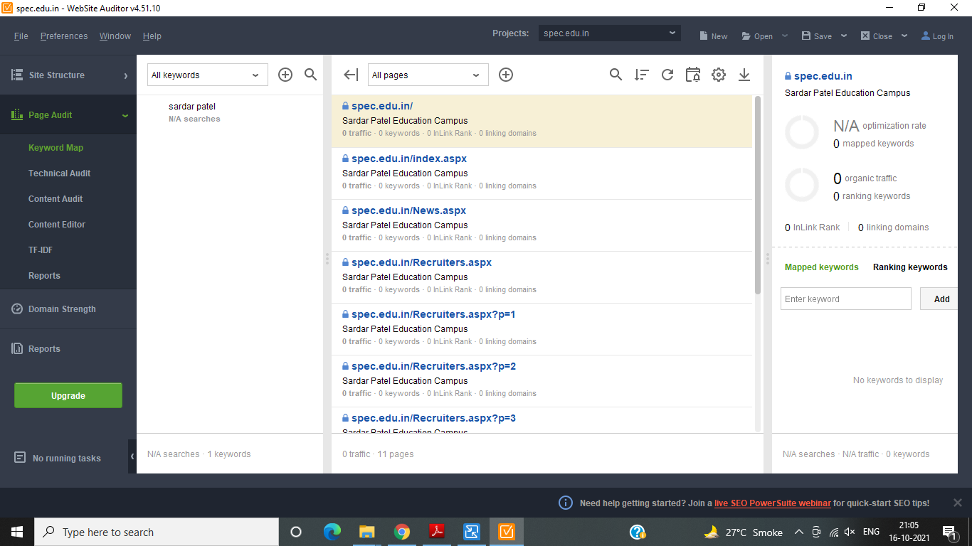

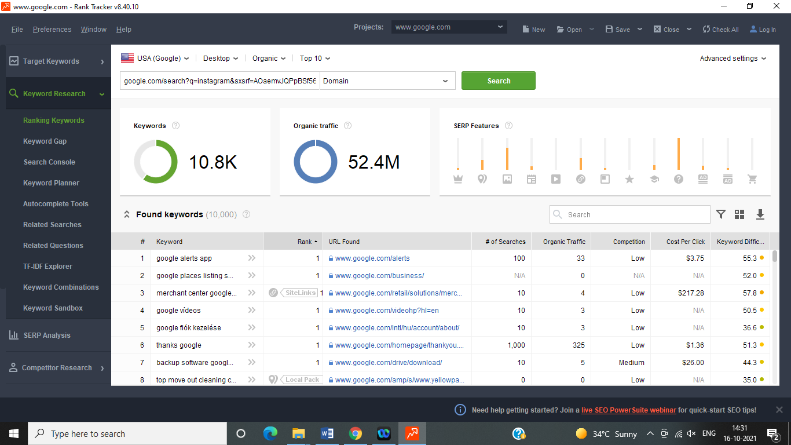

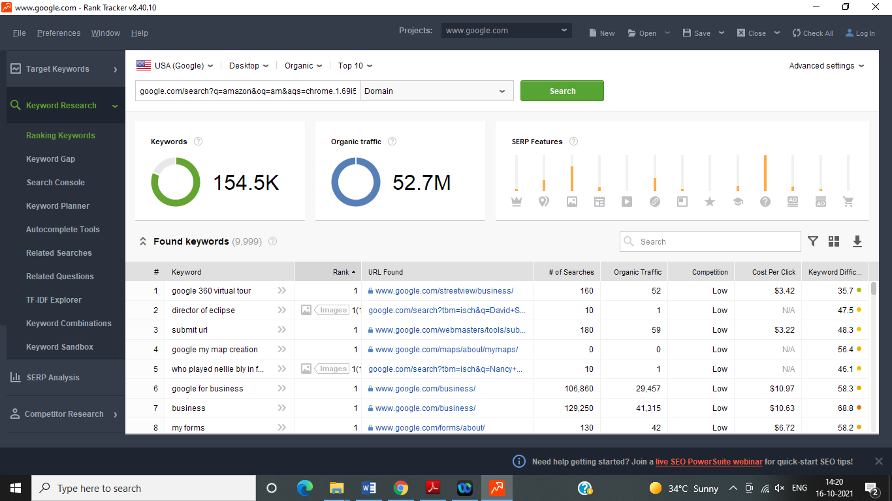

**CONCLUSION:**

In this Practical we have seen about how to search key word we are used for search keyword power shoot tools.

**Practical-7**

**Aim: Find the blogs which takes people to this site.**

**Search engine optimization**

Potential customers must be able to find your store using search engines. That’s why Shopify supports SEO best practices like customizable H1, title and meta tags.

Shopify also automatically generates sitemaps.xml files so new products and site changes show up on search engines quickly.

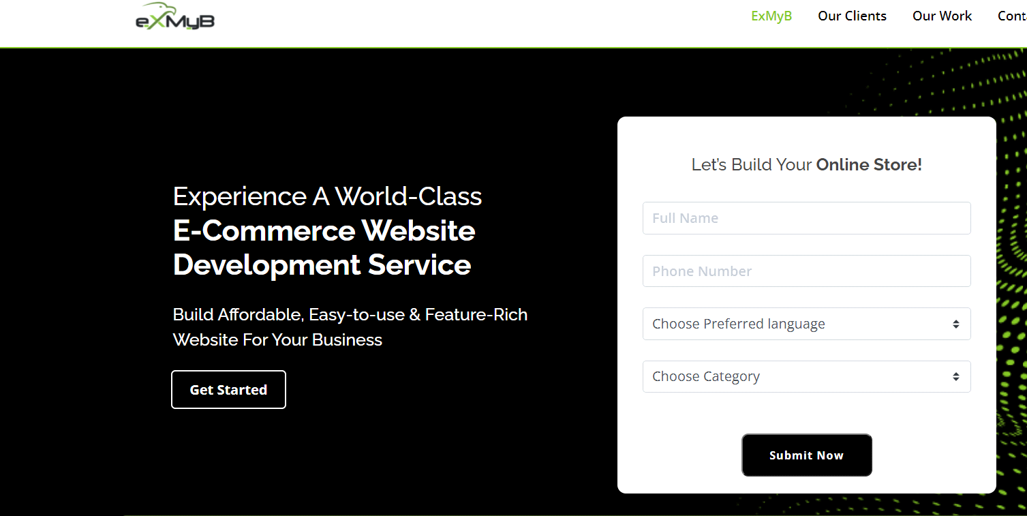

**Start accepting orders in minutes**

Shopify includes everything you need to set up your business website and start selling online.

It’s quick and easy to choose a theme, add your products, and begin accepting orders. You could make your first sale the same day you sign up!

**Extend the functionality of your storefront**

Shopify apps are a fast, easy way to add useful extra features to your website.

Apps give your store an edge over the competition by increasing your marketing capabilities, making your shop even easier to manage, improving your SEO, helping you track sales trends, and more.

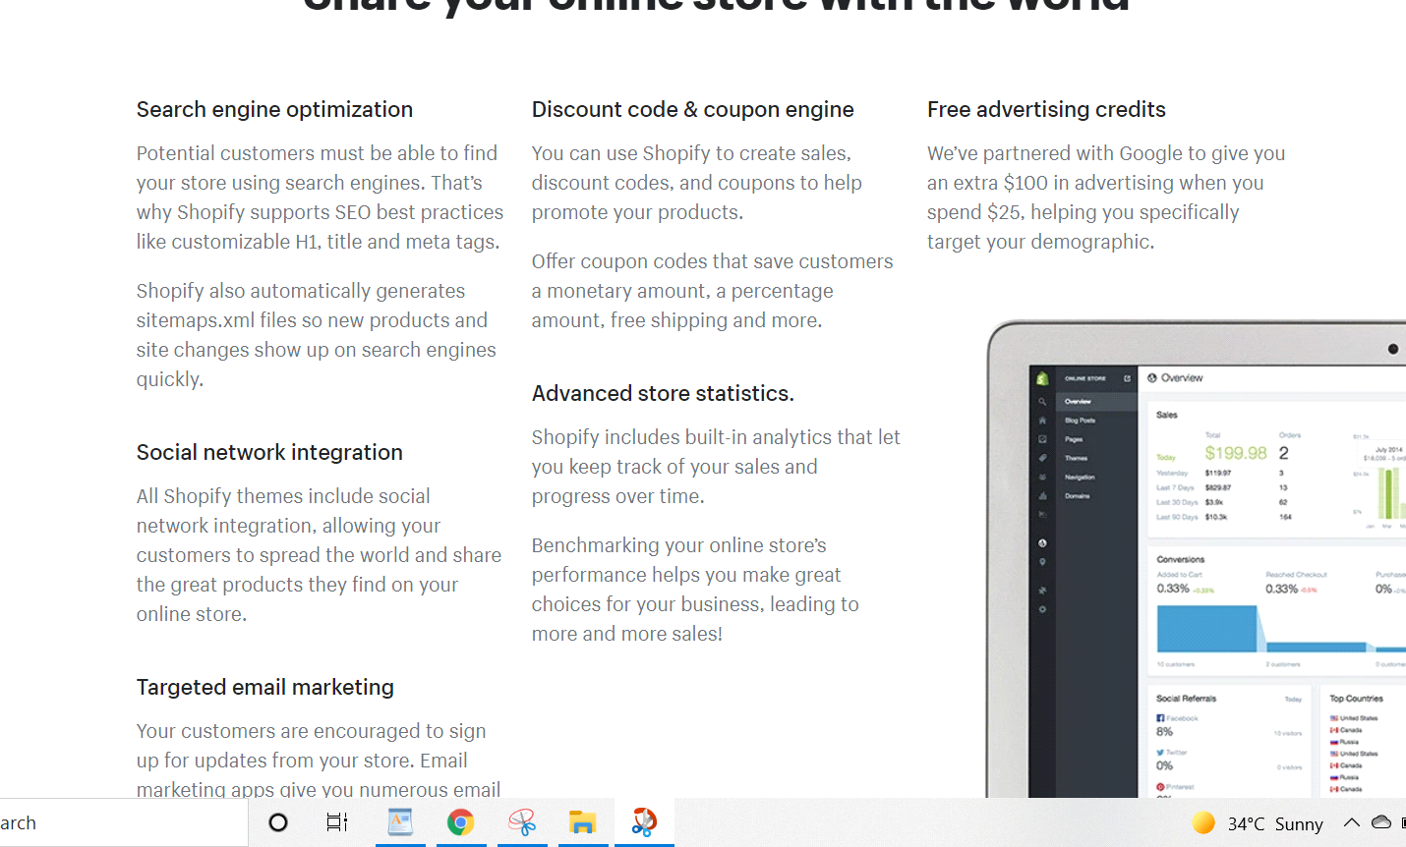

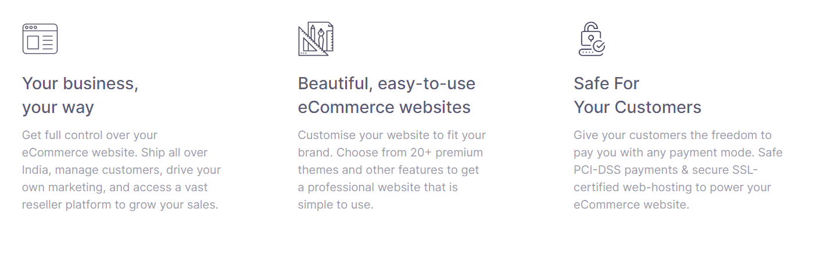

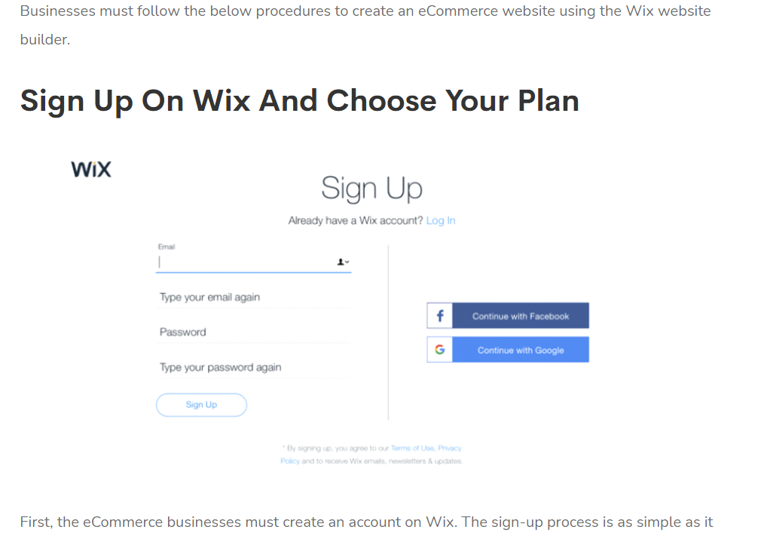

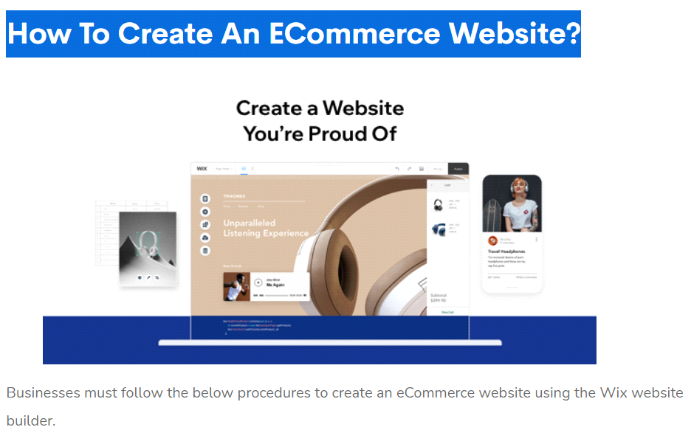

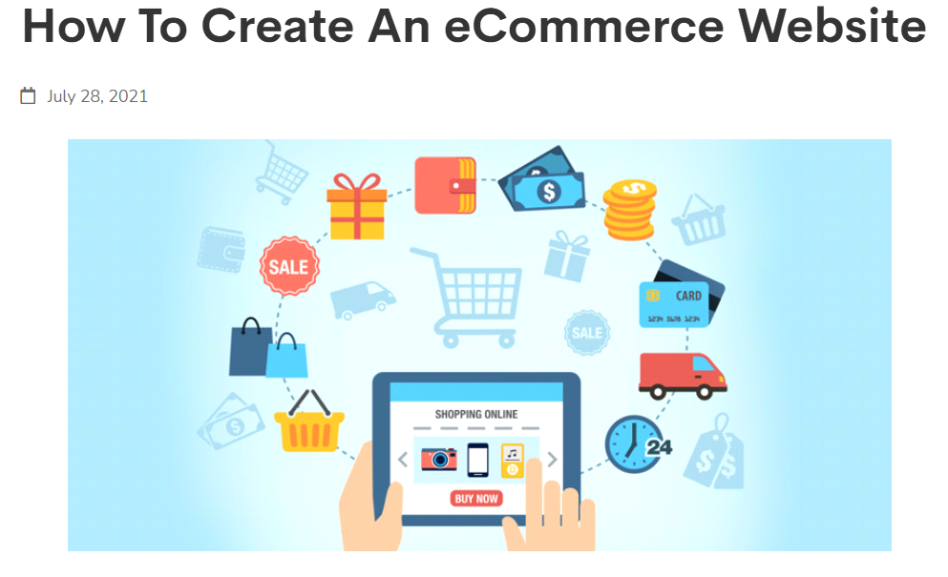

Detailed customer profiles

The Customer area in your shop admin lets you learn more about your customers and their shopping habits. You can find their contact info and order history at a glance.

Create customer groups

It’s easy to be organized with Shopify! Categorize and export customer lists based on location, purchase history, and more.

**How to Start a Blog in 6 Steps**

Pick a blog name. Choose a descriptive name for your blog.

Get your blog online. Register your blog and get hosting.

Customize your blog. Choose a free blog design template and tweak it.

Write & publish your first post. Share your thoughts with the world. The fun part!

Promote your blog. Get more people to read your blog with the proper marketing.

Make money blogging. Choose from several options to monetize your blog.

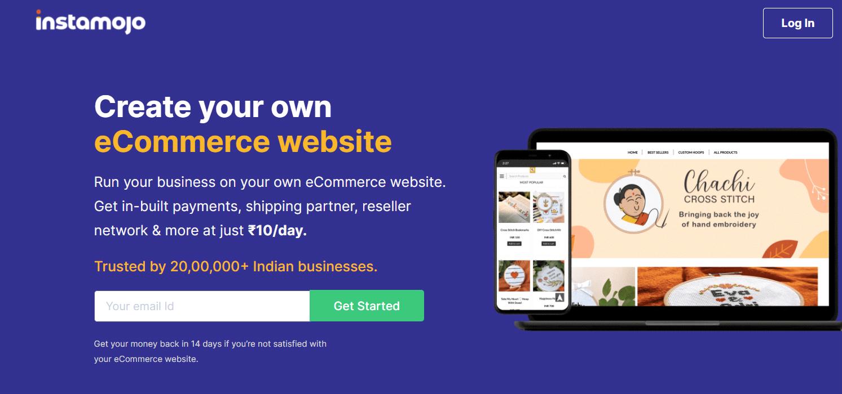

**CONCLUSION:**

In this experiment we learned about the page and create your site load time and perform practical to find the page load time for website as well as we came to know about how the components of the page load and how much time taken to load them. Find your blog and create a website. How to Start a Blog in 6 Steps.

**Practical-8**

**Aim: Try password attack to check the site is not vulnerable to this attack.**

There are several types of Attacks to check the site whether it is vulnerable or not, the following are the few examples of those attacks.

1. Phishing

2. Man-in-the-middle attack

3. Brute force attack

4. Dictionary attack

5. Credential stuffing

6. Keyloggers

The Below given image shows the brute force attacking method on a particular location in computer’s term the IP Address – 192.168.100.155.

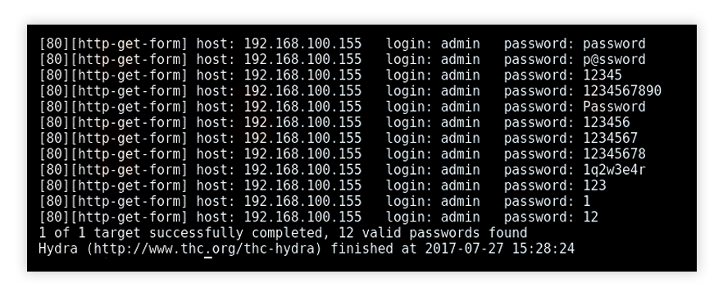

Similarly another way of attacking any website to check vulnerability is by phishing attack. Now how it is done, is given below:

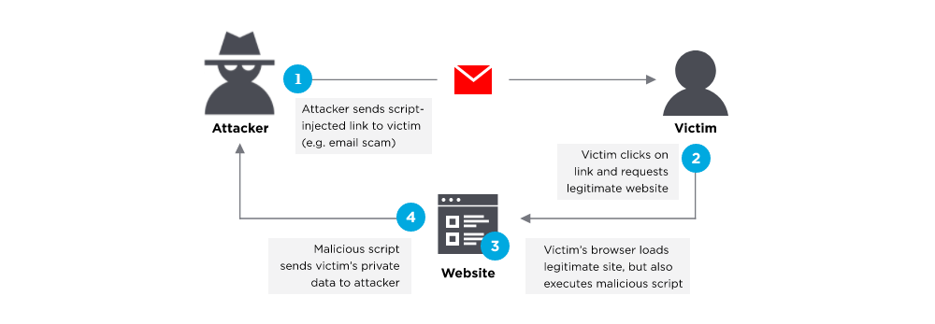

If we try to attack any website then, there are some login sessions and attempts, if you don’t get logged inside within that attempts then you will not be able to login again within some amount of time frame as shown below:

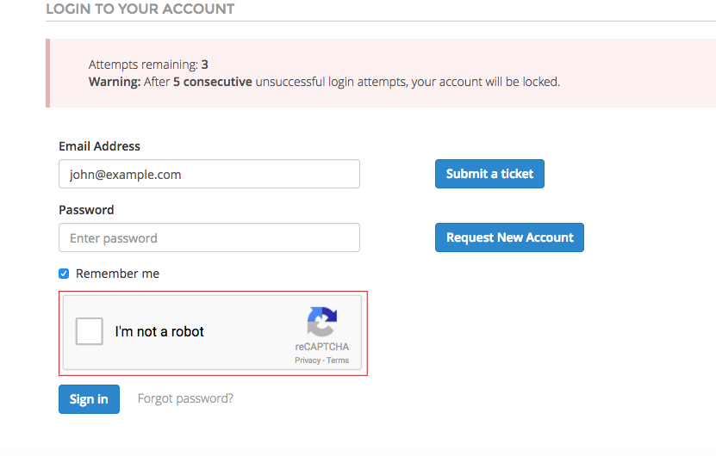

Now dictionary attacks are those kind of attacks where there are some pre default username and password dictionaries stored and while doing attack that dictionary is matched with the login id and password, as shown below:

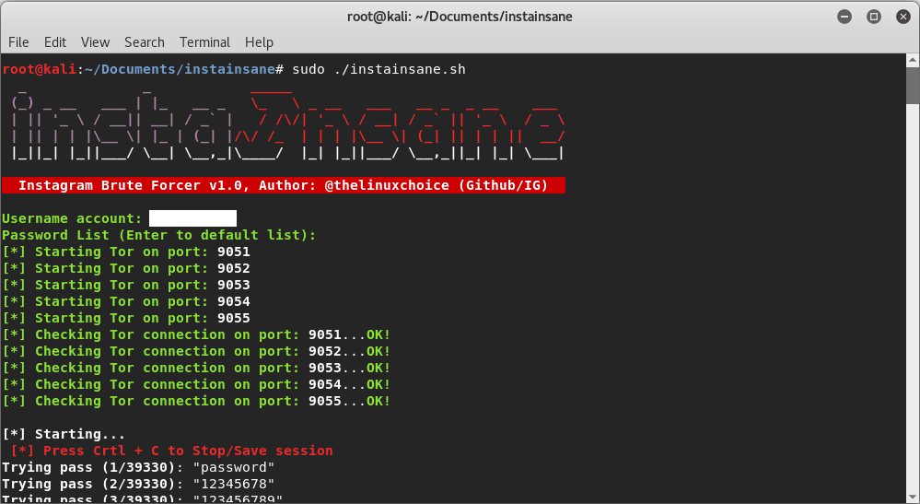

Hence, this are some different kinds of attacks that any hacker/middle man can do.

**CONCLUSION:**

In this experiment we learned about different types of attacks and vulnerability of websites and how any hacker can get inside any website by doing just simple attacks as explained above.